Name | Siddhesh Sonar
UID no. | 2021700063
Experiment No. | 3

AIM: | To implement and compare the Normal and Strassen’s matrix multiplication
Program 1
PROBLEM STATEMENT : | To implement normal matrix multiplication
ALGORITHM/  THEORY: | We can add, subtract, multiply and divide 2 matrices. To do so, we are taking input from the user for row number, column number, first matrix elements and second matrix elements. Then we are performing multiplication on the matrices entered by the user.  void multiply(int A[][N], int B[][N], int C[][N])  {  for (int i = 0; i < N; i++)  {  for (int j = 0; j < N; j++)  {  C[i][j] = 0;  for (int k = 0; k < N; k++)  {  C[i][j] += A[i][k]*B[k][j];  }  }  }  }  Time Complexity is : O(n^3)
PROGRAM: | #include <stdio.h>  #include <time.h>  void takeInput(int a[][2], char b)  {  for (int i = 0; i < 2; i++)  {  for (int j = 0; j < 2; j++)  {  printf("\nEnter %c%d%d = ", b, i + 1, j + 1);  scanf("%d", &a[i][j]);  }  }  }  void printMatrix(int a[][2])  {  for (int i = 0; i < 2; i++)  {  printf("\n");  for (int j = 0; j < 2; j++)  printf("%d\t", a[i][j]);  }  }  int main()  {  int a[2][2], b[2][2], c[2][2];  int c1, c2, c3, c4, c5, c6, c7;  clock_t start, end;  double time_taken;  printf("\nEnter the 4 elements of first matrix\n");  takeInput(a, 'a');  printf("\nEnter the 4 elements of second matrix\n");  takeInput(b, 'b');  printf("\n\nThe first matrix is\n");  printMatrix(a);  printf("\n\nThe second matrix is\n");  printMatrix(b);  start = clock();  c1 = (a[0][0] + a[1][1]) * (b[0][0] + b[1][1]);  c2 = (a[1][0] + a[1][1]) * b[0][0];  c3 = a[0][0] * (b[0][1] - b[1][1]);  c4 = a[1][1] * (b[1][0] - b[0][0]);  c5 = (a[0][0] + a[0][1]) * b[1][1];  c6 = (a[1][0] - a[0][0]) * (b[0][0] + b[0][1]);  c7 = (a[0][1] - a[1][1]) * (b[1][0] + b[1][1]);  c[0][0] = c1 + c4 - c5 + c7;  c[0][1] = c3 + c5;  c[1][0] = c2 + c4;  c[1][1] = c1 - c2 + c3 + c6;  printf("\n\nAfter performing multiplication\n");  printMatrix(c);  end = clock();  time_taken = ((double)(end - start)) / CLOCKS_PER_SEC;  printf("\nStressen's time : %f\n", time_taken);  return 0;  }
RESULT:

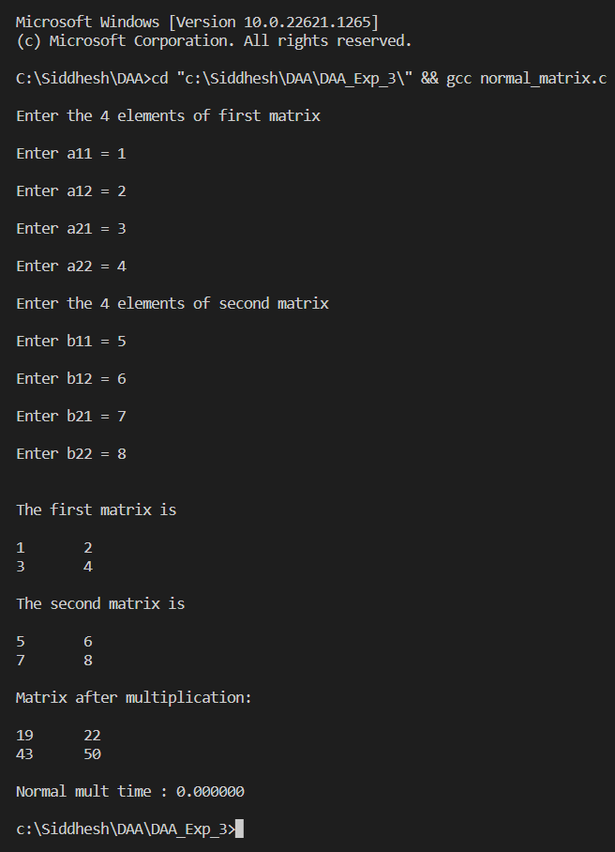

Program 2
PROBLEM STATEMENT : | To implement Strassen’s Matrix Multiplication
ALGORITHM/  THEORY: | Strassen algorithm is a recursive method for matrix multiplication where we divide the matrix into 4 sub-matrices of dimensions n/2 x n/2 in each recursive step.  - Given two matrices A and B, divide them into four sub-matrices each of size n/2, where n is the size of the original matrices.  - Compute seven products recursively using these sub-matrices:  M1 = (A11 + A22) x (B11 + B22)  M2 = (A21 + A22) x B11  M3 = A11 x (B12 - B22)  M4 = A22 x (B21 - B11)  M5 = (A11 + A12) x B22  M6 = (A21 - A11) x (B11 + B12)  M7 = (A12 - A22) x (B21 + B22)  - Compute the four sub-matrices of the result matrix C using these products:  C11 = M1 + M4 - M5 + M7  C12 = M3 + M5  C21 = M2 + M4  C22 = M1 - M2 + M3 + M6  - Combine these sub-matrices to form the final result matrix C.
PROGRAM: | #include <stdio.h>  #include <time.h>  void takeInput(int a[][2], char b)  {  for (int i = 0; i < 2; i++)  {  for (int j = 0; j < 2; j++)  {  printf("\nEnter %c%d%d = ", b, i + 1, j + 1);  scanf("%d", &a[i][j]);  }  }  }  void printMatrix(int a[][2])  {  for (int i = 0; i < 2; i++)  {  printf("\n");  for (int j = 0; j < 2; j++)  printf("%d\t", a[i][j]);  }  }  int main()  {  int a[2][2], b[2][2], c[2][2];  int c1, c2, c3, c4, c5, c6, c7;  clock_t start, end;  double time_taken;  printf("\nEnter the 4 elements of first matrix\n");  takeInput(a, 'a');  printf("\nEnter the 4 elements of second matrix\n");  takeInput(b, 'b');  printf("\n\nThe first matrix is\n");  printMatrix(a);  printf("\n\nThe second matrix is\n");  printMatrix(b);  start = clock();  c1 = (a[0][0] + a[1][1]) * (b[0][0] + b[1][1]);  c2 = (a[1][0] + a[1][1]) * b[0][0];  c3 = a[0][0] * (b[0][1] - b[1][1]);  c4 = a[1][1] * (b[1][0] - b[0][0]);  c5 = (a[0][0] + a[0][1]) * b[1][1];  c6 = (a[1][0] - a[0][0]) * (b[0][0] + b[0][1]);  c7 = (a[0][1] - a[1][1]) * (b[1][0] + b[1][1]);  c[0][0] = c1 + c4 - c5 + c7;  c[0][1] = c3 + c5;  c[1][0] = c2 + c4;  c[1][1] = c1 - c2 + c3 + c6;  printf("\n\nAfter performing multiplication\n");  printMatrix(c);  end = clock();  time_taken = ((double)(end - start)) / CLOCKS_PER_SEC;  printf("\n\nStressen's Multiplication time : %f\n", time_taken);  return 0;  }
RESULT:

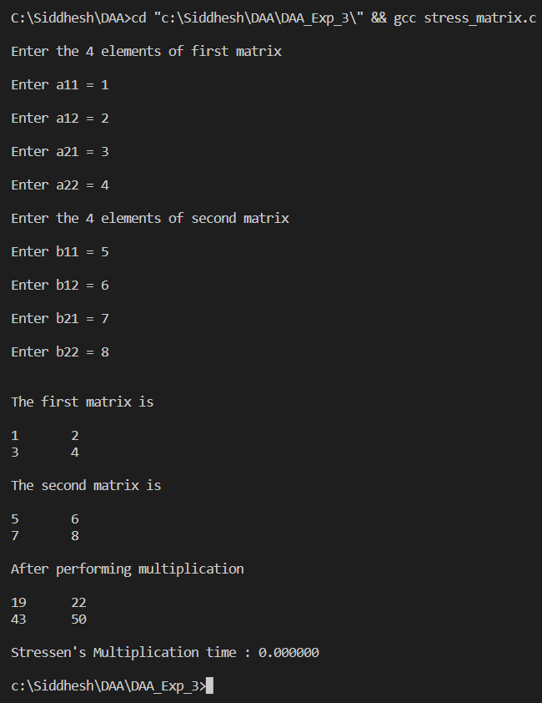
CONCLUSION: | Successfully implemented Strassen’s matrix multiplication in C program and also found that the time required for Strassen’s Algo (time complexity = O(n^2.807)) is slightly less than that required for normal method (time complexity = O(n^3)).

